Directions: This handout is intended for Gmail and Outlook email client users. You can always search for similar resources for your own client and swap out the directions.
Step 1. Get organized with folders

Gmail: There are NO folders in Gmail. They are called Labels.

Outlook: There are folders.

Step 2. Eliminate unwanted emails

Gmail: Mark or unmark emails in SPAM.

Outlook: Overview of the Junk Email Filter

Step 3. Schedule time for email

You should set up times in your calendar to check your email if your job does not require you to check email more often.

Step 4. Manage email alerts and follow-up

Gmail: Star emails in Gmail.

Outlook: Set up reminders in Outlook

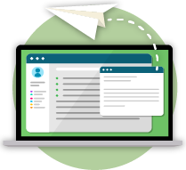 | Step 5. Answer emails briefly  Practice writing emails and share and discuss tones.

